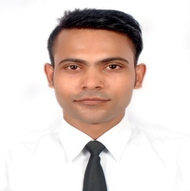

Contact Detail
Address | B-1086, Ground Floor, Sanhgam Gali, New Ashok Nagar 110096
Contact No | +917897339339 | Whatsapp No | +917897339339
Email ID | akashrockcoolgangwar@gmail.com | Facebook ID | /akash.gangwar3

Education
Qualification | Institution | Passing Year
10th | UP Board | 2010
12th | UP Board | 2012
BSC | CSJM University | 2015

Work Experience
Fresher

Hobbies
Photography
Listening Music
Net Surfing

Strengths
Work dedication
Team Coordination
Self Confident

Extra Activities
Safety Course Completes STCW 2010
- PSSR – Personal Survival & Social Responsibility (PSSR)
- PST- Proficiency in survival Techniques (PST)
- FPFF - Fire Prevention & Fire Fighting (FPFF)
- EFA - Elementary First Aid (EFA)
- HUET – Helicopter Underwater Training (HUET)

Passport Detail.
Passport Number | P04808762 | Place of Issued | Lucknow UP India
Date of Issued | 30th September 2016 | Date of Expiry | 29th September 2026

Personal Detail

Father ‘s Name | : | Mr. Arun Kumar Gangwar
Date of Birth | : | 15th Oct. 1997
Nationality | : | Indian
Material Status | : | Single
Languages Know | : | Hindi & English

I hereby declare that the information given above is true at the best my knowledge.

Date | :
Place | :

